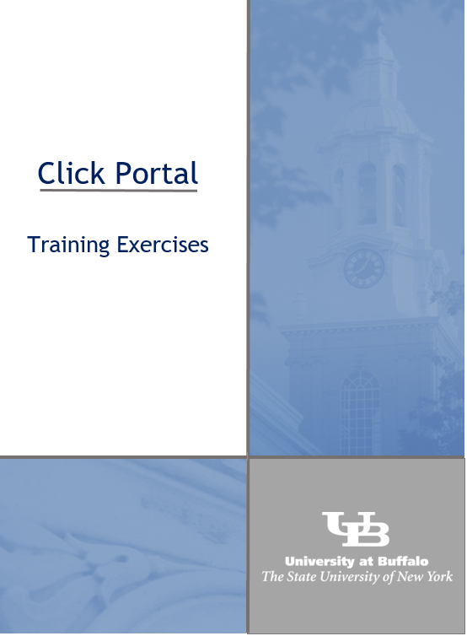
May 2023
COI Module
Disclosure Submission Guide

Page left intentionally blank

COI Module – Disclosure Submission Guide
Table of Contents
What is the Click Portal? 4
COI Module Description 5
Getting a Click Account 5
Logging into the Click Portal 6
Basic Navigation 8
My Inbox 8
My Disclosures 9
The Workspace 10
SmartForms 11
Filtering and Sorting Data 12
Filtering Data 12
Using Add Filter 13
Sorting Data 13
Before You Start 14
Creating an Annual Certification 14
Institutional Responsibilities 16
Training and Education Information 18
Required CITI Courses 18
Logging into CITI 19
What to Disclose 20
Disclosure Details 22
Equity Shares/Options/Private Ownership in External Company 23
Consulting, Advisory, and Speaking Compensation 23
Editorial Compensation 24
Intellectual Property Rights Compensation 24
Sponsored Travel 25
Board Member Compensation 26
Significant Obligations 26
Disclosure Summary 27
Disclosure Details 27
Assurance and Certification 28
Submitting Disclosure(s) for Review 30
Recalling Submitted Disclosures 30
The Review Process 31
Clarification and Change Requests 31
Review the Request Details 31
Respond to the Request 32
Management/Mitigation Plans 32
Respond to the Request 32
Update Your Certification 34

What is the Click Portal?
The SUNY Pre-Award and Compliance System (PACS) is a multi-year collaboration created to support investigators and students along with compliance and research administrative staff by giving them a new administrative tool - the Click Portal.
Click automates the submission, review, and approval processes while managing all major administrative aspects of the research and compliance lifecycle – from proposal development and submission through compliance checks, negotiations, award setup and award management, to eventual project closeout.
This system integrates the following aspects of research administration into a single system:
- Institutional Review Board (IRB)
- Institutional Animal Care and Use Committee (IACUC)
- Grants Management
- Conflicts of Interest (COI)
- Research Agreements
- Safety
Under the stewardship of UB’s Office of the Vice President for Research and Economic Development, this platform allows the University at Buffalo to achieve a new level of uniformity and efficiency, while also producing valuable data analytics that can guide future decisions.
UB is helping lead this SUNY-wide effort and was the first campus to implement the Click Portal, beginning with the IRB module in Fall 2015.

COI Module Description
The Conflict of Interest (COI) Module provides an electronic system for management of research-related conflict of interest disclosures. It ensures the prevention of bias and helps avoid a circumstance in which a researcher’s personal interest or relationships might compromise the integrity of research at the University.
All principal investigators must have a current financial disclosure on file prior to applying for extramural funding. Annually, UB's filing deadline is November 1st of each year. Click COI will email notifications mid-September alerting individuals that they must complete their financial disclosure. A current annual financial disclosure must be completed prior to applying for extramural funding. Researchers also must file within 30 days of discovering or acquiring a significant financial interest (e.g., through purchase, marriage, or inheritance).

Getting a Click Account
Accounts have been created for all faculty and staff at the University at Buffalo in preparation for campus-wide implementation of the Click Portal. Users will log into the system using their UBIT Name and Password.
If your login attempt is unsuccessful, or you are a student participating on a research team, please follow the instructions below to request an account:
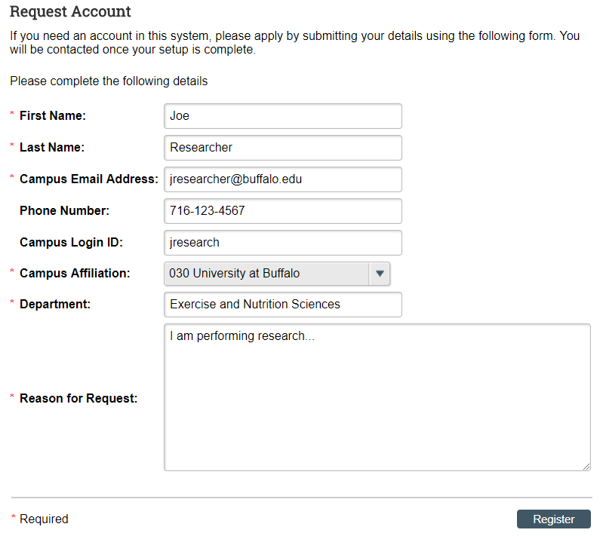
- Navigate to the UB Research Services: Training and Development webpage at https://www.buffalo.edu/research/research-services/training.html. Locate the Click Portal Registration area on the right of the page, and click on the registration link.
- Complete the Request Account form at the bottom of the page, and then click the Register button. Be sure to select the University at Buffalo as your Campus Affiliation.

You will receive an email notification when your account has been activated.

Logging into the Click Portal
- Navigate to the UB Research and Economic Development page at http://www.buffalo.edu/research.html
- Locate the Quick Links section in the center of the page.
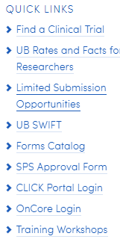
- Click on the Click Portal Login link.

- Enter your UBIT Name and Password in the fields, and then click the Log In button.
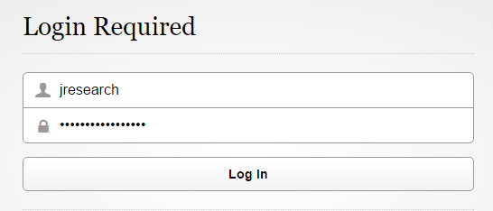

Page left intentionally blank

Basic Navigation

My Inbox
Each time you log into the Click Portal, you will be taken to your Inbox. This area of the portal contains a list of all submissions that currently require you to take an action.
My Inbox is divided into two tabbed pages:
- Compliance Tasks – This tab contains a list of your IRB, IACUC, and Safety submissions that currently require you to take an action.
- SPO Tasks – This tab contains a list of your Grants, Agreements, and COI Disclosures that currently require you to take an action.
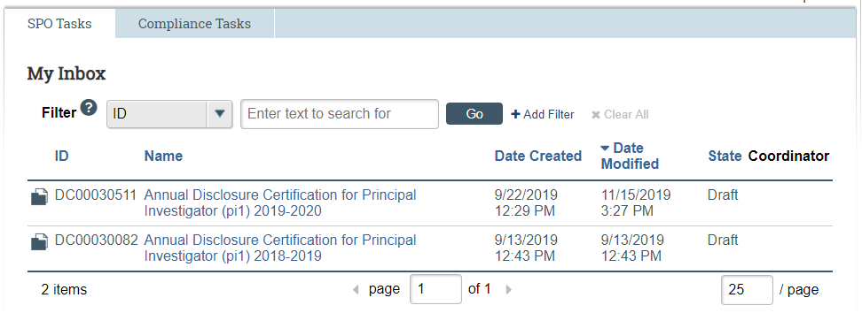
The listings within My Inbox can be sorted by using the Filter by option. This option will allow you to search by ID number, Name, Date Created, Date Modified, or State.
- To open a submission, click on its Name. When you open a submission, you will be brought to its Workspace.
- You can return to My Inbox at any time by clicking the My Inbox tab in the navigation menu at the top of the screen.

My Disclosures
You may navigate directly to the COI module by clicking the COI tab in the navigation menu at the top of the screen.
The My Disclosures area is divided into three tabs:
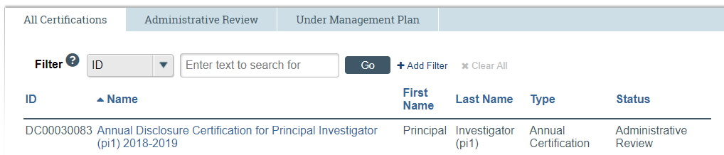
- All Certifications – This tab shows all your disclosure certifications, regardless of state.
- Administrative-Review – This tab lists all of your COI annual disclosure certifications currently under COI review.
- Under Management Plan – This tab lists all of your disclosures that are currently under a Management Plan to mitigate any risk.
On the left side of the screen, you will see links to Activities you can perform, as well as Shortcuts to other areas of the module.
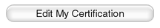
Activities:
- Edit My Certification – Edit and submit a Certification.
Shortcuts:
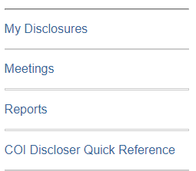
- My Disclosures – See a list of all of the Annual Disclosure Certifications you have created in the COI module.
- Meetings – Meeting information for COI Administrators and Committee Members.
- Reports – Generate Reports on any submissions that you have made to the COI module.
- COI Guides – Manuals and guides to assist you in working in the COI module.

The Workspace
Click on the Name of a disclosure certification to open the submission. Once you open a certification, you will be taken to the Workspace.
The Workspace allows you to:
- View the certification contents and details, including all actions that have been performed on it
- Perform actions on the certification
Top Navigation
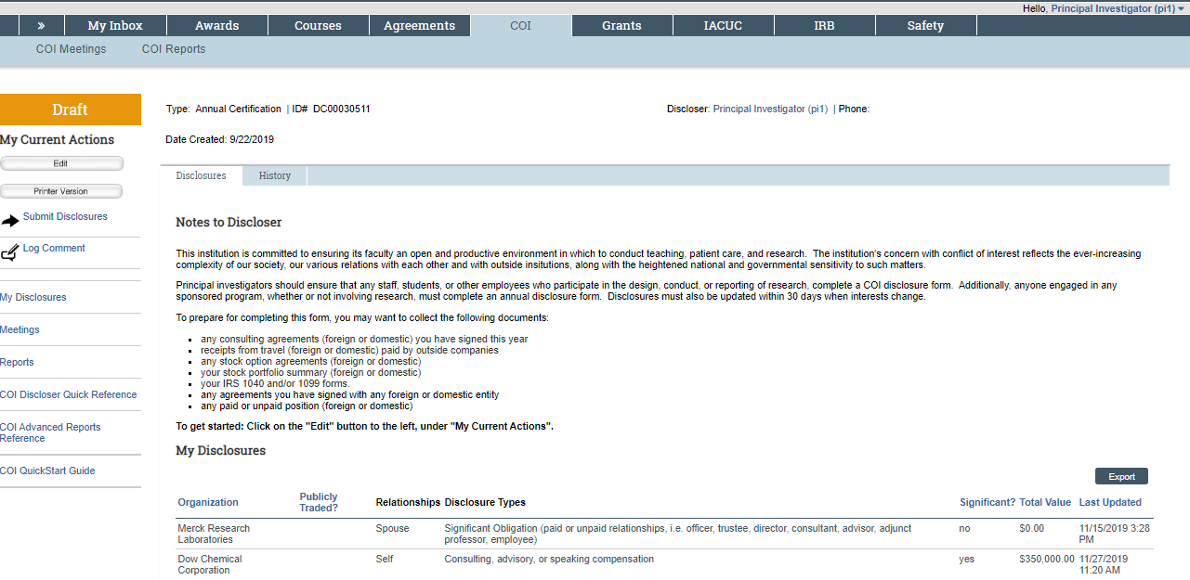
Header
Disclosures Tab
History Tab
Shortcuts
Activities
The key elements in the Workspace are:
- Header – Links to your profile and lets you log off
- Top navigation menu – Links to the different modules within the Click Portal
- Activities – Actions that can be taken based on a submission’s current State and your assigned role within the module
- Disclosures tab– Instructional notes for the Discloser, and a list of disclosures made previously (if applicable).
- History tab– Actions taken previously on this submission
- Shortcuts – Quick links to other frequently used areas of the module

SmartForms
To open a certification from its Workspace, click on the Edit button.
Note: This button may also be labeled View,
dependent upon the State of the submission you are opening.
Certifications are comprised of several pages known as SmartForms. They are referred to as ‘smart’ because the portal will branch to add additional forms to your submission based on your responses to questions on the pages.
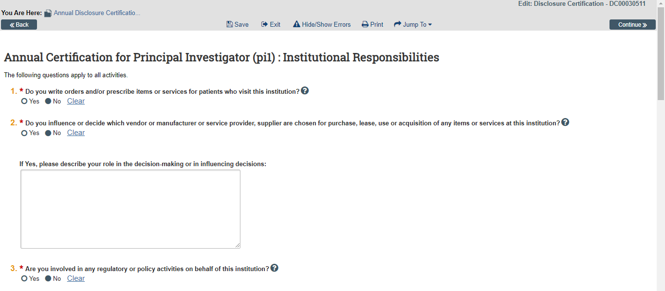
- The Continue and Back buttons will move you forward or back one page in the forms; the Continue button also saves your work.
- The navigation bar at the top and bottom of each page will allow you to perform the following actions:
  - Save – Saves your work for the current page
  - Exit – Exits the forms and returns you to the Workspace
  - Hide/Show Errors – Performs a check on every page within the forms to ensure that all required fields have been completed
  - Print – Prints the current page
  - Jump to: - Allows you to see and navigate to all pages within the forms
- Any item on a SmartForm that has a red asterisk (*) next to it is a required field.
- Clicking on the blue icons ( ) next to items will open a window that will offer assistance with completing the field.

Filtering and Sorting Data
Many pages contain tables you can filter and sort to help you find the data you want.

- Filtering reduces the list to only the data that meets the criteria. The advanced filter lets you combine multiple filter criteria together.
- Sorting displays the data in ascending or descending order by a particular column.

Filtering Data
- Select the column to Filter by from the drop-down menu. The menu lists only the columns you can Filter by.

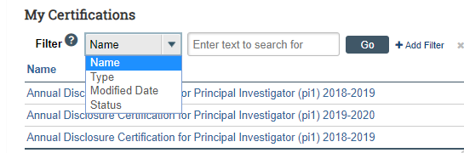
Note: To combine multiple filter criteria, such as Name,
Type, and Modified Date, use +Add Filter.

- In the next box, type the beginning characters for the items you want to find. If you do not know the beginning characters, type a % symbol as a wildcard before the characters.
Examples:
- 71 shows all items beginning with 71
- %71 shows all items containing 71 in any position

Note: For examples and a list of operators you can use, click the Help icon.

- Click Go to apply the filter. The table shows only those rows that are an exact match. If you do not see the expected items in the list, click Clear All in the Filter by area to remove the filter.

Using Add Filter

- In the Filter area, click Add Filter.

- Enter filter criteria as explained in the previous section.
- To add additional criteria, click Add Filter again.
- Click Go to apply the filters. The table shows only those rows that match all the filter criteria.

Sorting Data

Click the column header you wish to sort by. Click it a second time to reverse the sort order. The arrow indicates the column by which the data is sorted and the sort order, either ascending (up arrow) or descending (down arrow).

Note: If the column header is not a link, you cannot sort by that column.

Before You Start
Before you submit a certification, gather the following information:
- Any consulting agreements you have signed this year
- Receipts from travel paid by outside companies
- Any stock option agreements
- Your stock portfolio summary
- Your IRS 1040 and/or 1099 forms

This information will help you to complete the forms.

Creating an Annual Certification
Prior to November 1st each year, you will receive an email notification requesting that you create your Annual Certification.
To begin the process of creating an Annual Certification, please complete the following steps:
- Click the link in the notification email.
- If you are not already logged in to the Click Portal, you will be prompted to sign in.

- The Annual Certification will open, and you can begin entering your information.

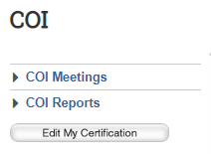
If you have lost or deleted the notification email, please complete the following steps:
- Log in to the Click Portal.
- Click the COI option in the top navigation menu.
- Click the Edit My Certification button.
The sections on the next few pages will provide step-by-step information on some of the general SmartForms you may be asked to complete as part of submitting an Annual Certification to the COI for review.
Note: If you have submitted a certification in the Click Portal before,
the forms will show your previous answers. Update them appropriately.

Page left intentionally blank

Institutional Responsibilities
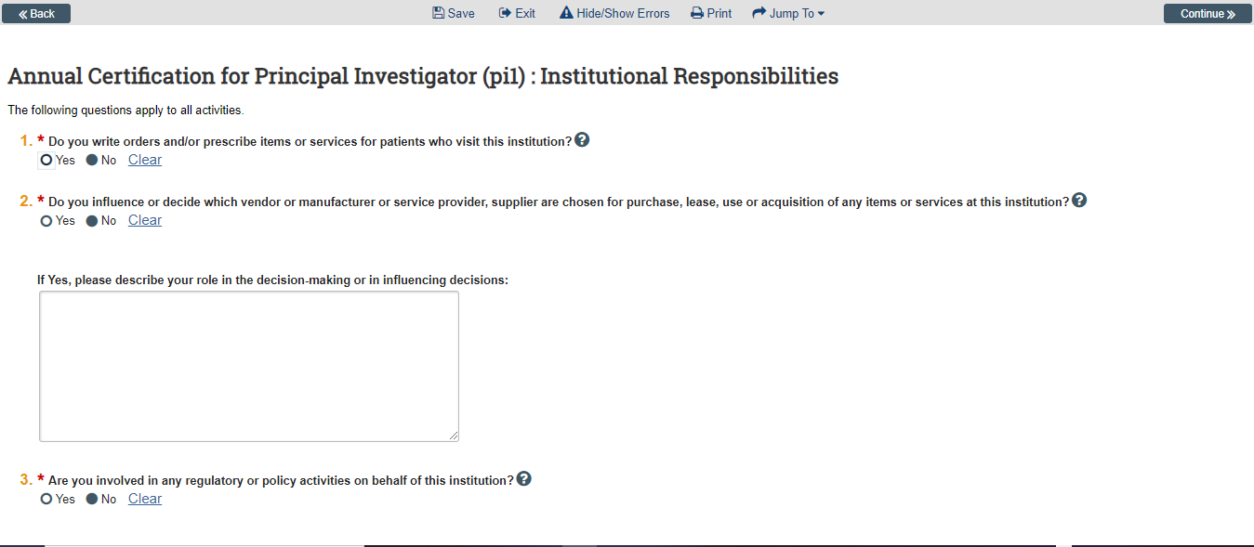
- Indicate if you write orders and/or prescribe items or services for patients who visit this institution (e.g., medical orders, prescriptions, therapy, diagnostics, or any medical devices).
- Indicate if you influence or decide which manufacturers, service providers, or suppliers are chosen for purchase, lease, use, or acquisition of any items or services at this institution.
This broad and inclusive group includes, but is not limited to:
- Medical orders, equipment, and supplies of any kind, whether durable, capital, or disposable, prescriptions, therapy, diagnostics, and medical devices
- Any and all services, such as laundry, housekeeping, landscaping, professional services, staffing, equipment, furniture, and travel
If you have answered Yes to this item, please use the text box provided to indicate your area(s) of influence.
- Indicate if you are involved in any regulatory or policy decisions on behalf of this institution.
Regulatory and policy activities include membership on any committee with decision-making or decision-influencing authority such as compliance committees (IRB, IACUC, Biosafety, etc.), advisory committees, or any committee reporting to or advising the President, Board of Directors, or your campus equivalent to a board of trustees.
If you have answered Yes to this item, please use the text box provided to indicate your area(s) of influence.
- Indicate if you employ or supervise anyone known to you to be related to you by blood, adoption, or marriage, at this institution.
If you have answered Yes to this item, please use the text box provided to name the person, their title, your supervisory relationship to the person at work and your family relationship to the person and any management plans currently in place.
- Indicate if you hold a position of executive leadership at this institution.
Examples of executive leadership include President, Provost, Associate/Assistant Provost, Vice President, Associate/Assistant Vice President, Dean, Associate/Assistant Dean, Department Chair, Compliance Committee Chair, Controller, or other similar positions.
- Indicate if you are directly or indirectly involved in the teaching, instruction, or education of students at this institution.
- Indicate if you are directly or indirectly involved in any research at this institution? This includes, but is not limited to, being listed on any funding proposal, awarded grant, IRB, or IACUC submission.
- Indicate if you are a Department Chair (or designee for a Department Chair) who certifies scientific merit on IRB submissions.
- Indicate if you or your spouse are employed by:
- A vendor or supplier of goods or services (foreign and domestic) to this institution or other organization
- An entity, foreign and domestic, that sponsors research at this institution or other organization
- A sub-recipient, foreign and domestic, of sponsored funds at this institution or other organization
If you have answered Yes to this item, please enter the Name of the Employer(s), your Spouse’s Job Title(s), and indicate if your spouse has the authority to make significant business decisions on behalf of their employer.

Click the Continue button to save your work and move to the next page within the SmartForms.

Training and Education Information
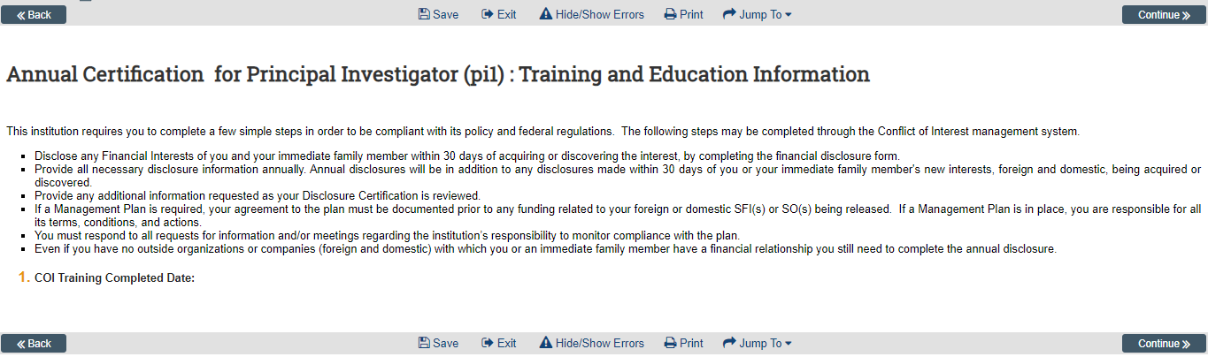
There are no fields to update on this page; a connection between the Click Portal and CITI will automatically add course information for any CITI Program courses you have taken related to COI. At present, there are some issues with integration between the two systems. These issues have caused the COI Administrator to manually verify CITI completion if it does not appear in the COI module.
Click the Continue button to and move to the next page within the SmartForms.

Required CITI Courses

All courses must be the University at Buffalo prescribed CITI courses. Similar CITI courses from other institutions will not be accepted. However, some of the modules in those courses may be applied automatically by CITI to your UB CITI courses.

For Social/Behavioral/Education Research the following are required:
- Human Research Curriculum, Social & Behavioral Research Investigators Basic or Refresher Course completed within the past 3 years.
- Social and Behavioral Responsible Conduct of Research Course Basic or Refresher Course completed within the past 3 years. *

*Currently the in-person GRP training for non-clinical researchers conducted by UB can be substituted for the above indicated RCR course. The IRB has information on the in-person courses on record and will verify this upon protocol submittal.

For Biomedical/Clinical Research the following are required:
- Human Research Curriculum, Biomedical Research Investigators Basic or Refresher Course completed within the past 3 years.
- CITI Good Clinical Practice Course Basic or Refresher Course completed within the past 3 years. **

**Currently the in-person GRP/GCP training for clinical researchers (parts I and II) conducted by UB can be substituted for the above indicated RCR and GCP courses. The IRB has information on the in-person courses on record and will verify this upon protocol submittal.
Note: It is not required that you pay for CME credit for the purpose of meeting UB’s human subjects requirement. If you wish to obtain CME credit, you may do so at your own expense.

Logging into CITI
- Navigate to http://www.citiprogram.org
- Enter your Username and Password.
If you have never had a CITI account, create one by clicking the Register button. When creating a new account, be sure to indicate SUNY-Buffalo (University at Buffalo) as your institution and use your UBIT email address for any email addresses requested.
If you have a CITI account with another institution, you can log into that account and then add an affiliation with SUNY-Buffalo (University at Buffalo) by clicking on the Click here to affiliate with another institution link toward the bottom of the CITI Main Menu page. Be certain to enter your UBIT email address for any email addresses requested.

What to Disclose
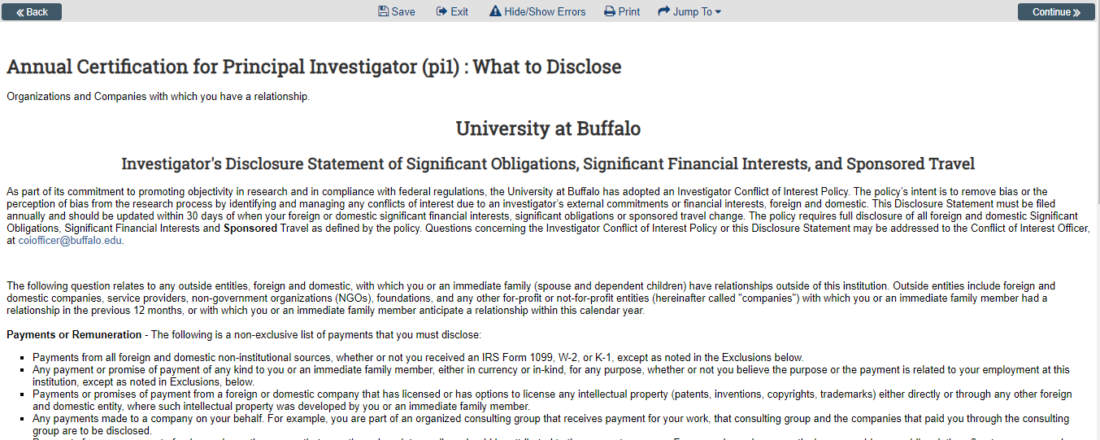
As part of its commitment to promoting objectivity in research and in compliance with federal regulations, the University at Buffalo has adopted an Investigator Conflict of Interest Policy. The policy’s intent is to remove bias or the perception of bias from the research process by identifying and managing any conflicts of interest due to an investigator’s external commitments or financial interests, foreign and domestic.
This page maintains a current listing of obligations, financial interests, and sponsored travel items that should be disclosed as a part of your Annual Certification. Questions concerning the Investigator Conflict of Interest Policy or your Disclosure Statement may be addressed to the Conflict of Interest Officer, at coiofficer@buffalo.edu.
The Annual Certification Disclosure requires you to indicate if there are any outside entities with which you or an immediate family member had a relationship in the previous 12 months, or with which you or an immediate family member anticipate a relationship within this calendar year.
- Indicate if there any outside organizations or companies (foreign and domestic) with which you or an immediate family member have a relationship.
Click the Continue button to and move to the next page within the SmartForms.
If you have answered No to this question,
please follow the instructions on the Assurance and Certification page.
If you have answered Yes, please continue to the Disclosure Details page.

Page left intentionally blank

Disclosure Details
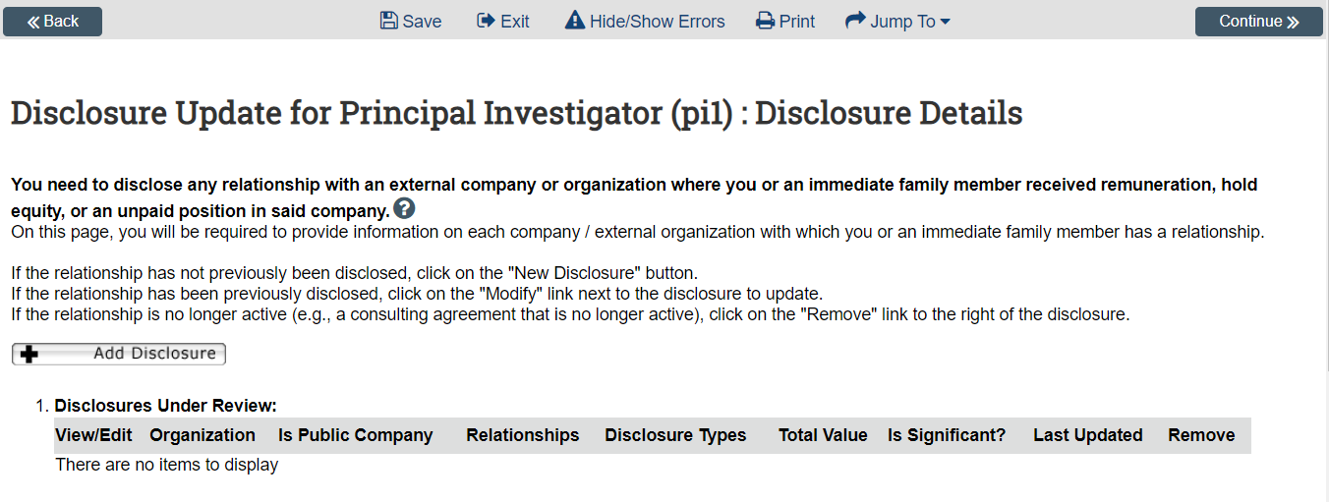
You need to disclose any relationship with an external company or organization where you or an immediate family member received remuneration, hold equity, or an unpaid position in said company. On this page, you will be required to provide information on each company/external organization with which you or an immediate family member has a relationship.

- Click the Add Disclosure button.
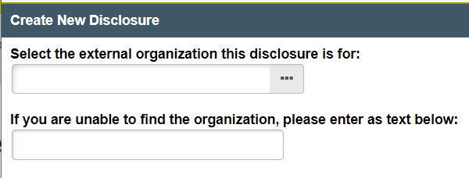
  - Click the ellipsis to open the Organization database.
  - Enter the Name of the organization with which you have a relationship, and click the Go button.
  - Locate the appropriate Organization, and click the radio button to the left of the Name. If you are unable to locate the Organization within the database, use the blank field provided to enter its Name.
  - Click the OK button.
- Place a checkmark to the left of the individual (e.g., Self, Spouse, Dependent Child) that has a relationship with the Organization.
- Place a checkmark to the left of the Type(s) of relationship you or your immediate family member have with the Organization.
Click the Continue button to save your work and move to the next page within the SmartForms.
The following page(s) will appear dependent upon your selection of the Type(s) of relationship you or an immediate family member have with an Organization.

Equity Shares/Options/Private Ownership in External Company
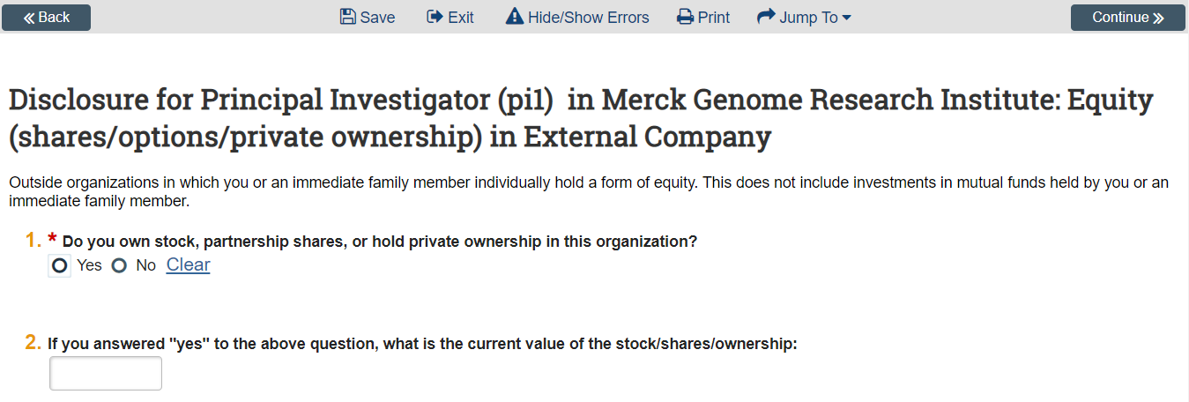
- Indicate if you own stock, partnership shares, or hold private ownership in this Organization.
- If you answered Yes to Item 1, indicate the current value of the stock/shares/ownership.
- Indicate if you own stock options or any other form of equity in this Organization.
- If you answered Yes to Item 3, indicate the current value of the options or other form of equity.
Click the Continue button to save your work and move to the next page within the SmartForms.

Consulting, Advisory, and Speaking Compensation
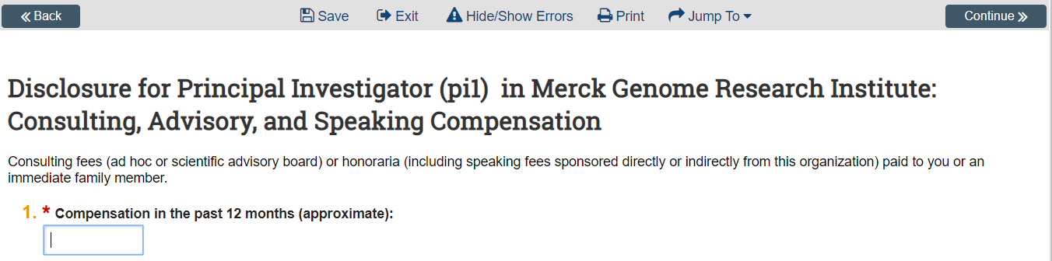
- Indicate the approximate dollar amount of compensation in the past 12 months.
Click the Continue button to save your work and move to the next page within the SmartForms.

Editorial Compensation
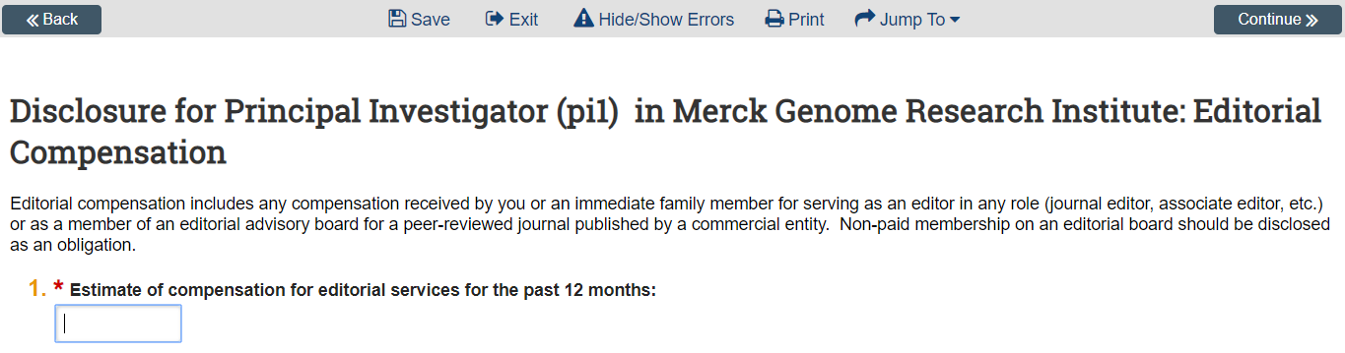
- Indicate the approximate dollar amount of compensation for editorial services in the past 12 months.
Click the Continue button to save your work and move to the next page within the SmartForms.

Intellectual Property Rights Compensation
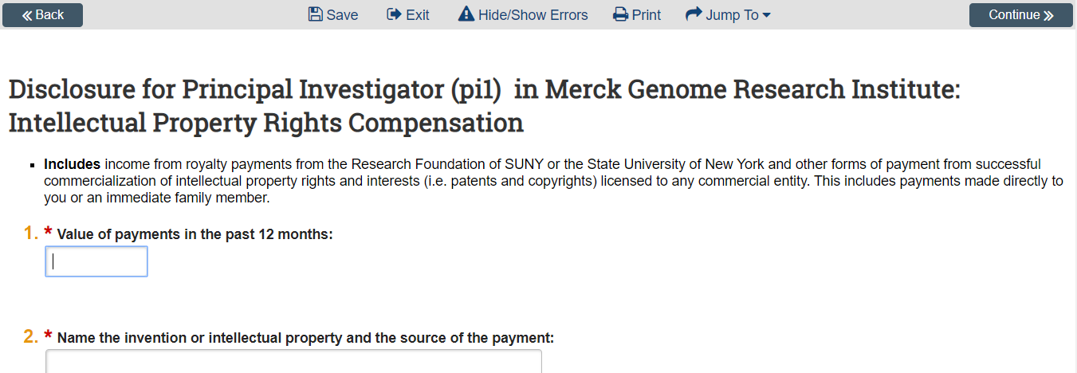
- Indicate the value of payments in the past 12 months.
- Name the invention or intellectual property and the source of the payment.
Click the Continue button to save your work and move to the next page within the SmartForms.

Sponsored Travel
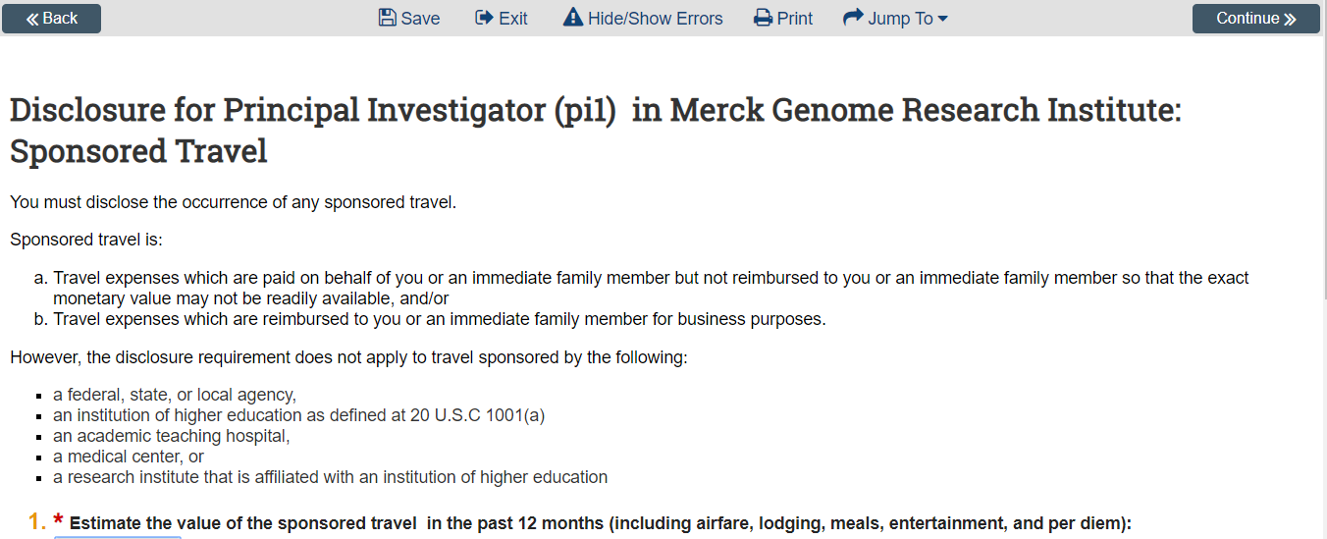
Sponsored Travel is:
- Travel expenses which are paid on behalf of you or an immediate family member but not reimbursed to you or an immediate family member so that the exact monetary value may not be readily available, and/or
- Travel expenses which are reimbursed to you or an immediate family member for business purposes.
However, the disclosure requirement does not apply to travel sponsored by the following:
- a federal, state, or local agency,
- an institution of higher education as defined at 20 U.S.C 1001(a)
- an academic teaching hospital,
- a medical center, or
- a research institute that is affiliated with an institution of higher education
- Provide an estimate of the value of the Sponsored Travel in the past 12 months (including airfare, lodging, meals, entertainment, and per diem).
- Provide the Destination, Duration, and Purpose for each trip sponsored by this outside entity.
  - Click the Add button.
  - In the pop-up window, indicate the Destination, Duration, and Purpose of the travel.
  - Click the OK button, or click OK and Add Another if you have another Destination to add.
  - Click the Update button if you need to modify any of your travel claims.
Click the Continue button to save your work and move to the next page within the SmartForms.

Board Member Compensation
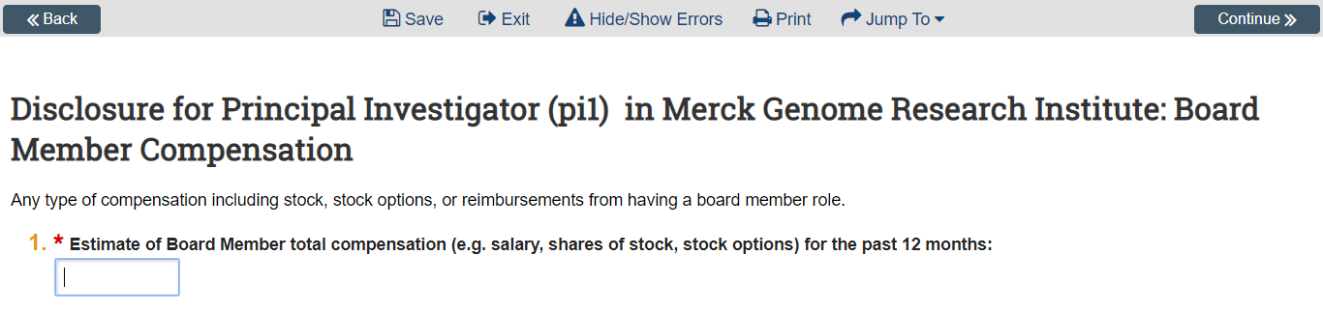
- Provide an estimate of total Board Member Compensation (e.g. salary, shares of stock, stock options) for the past 12 months.
Click the Continue button to save your work and move to the next page within the SmartForms.

Significant Obligations
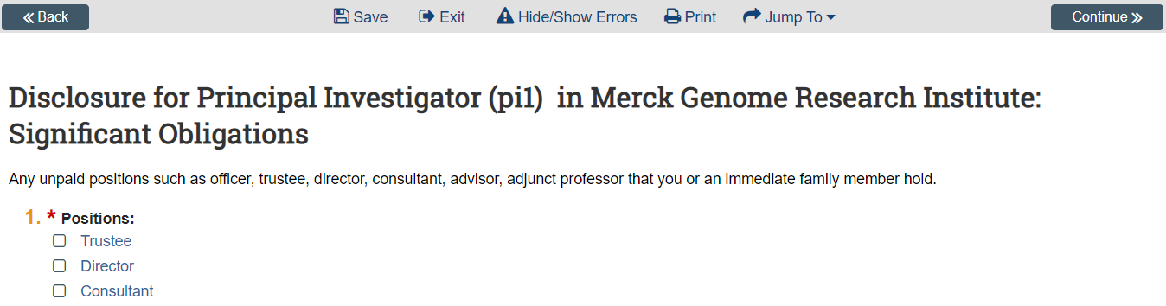
- Place a checkmark to the left of any unpaid Position(s) (e.g., officer, trustee, director, consultant, advisor, adjunct professor) that you or an immediate family member hold.
- If you placed a checkmark to the left of the Other option, please describe the position in the field provided.
Click the Continue button to save your work and move to the next page within the SmartForms.

Disclosure Summary
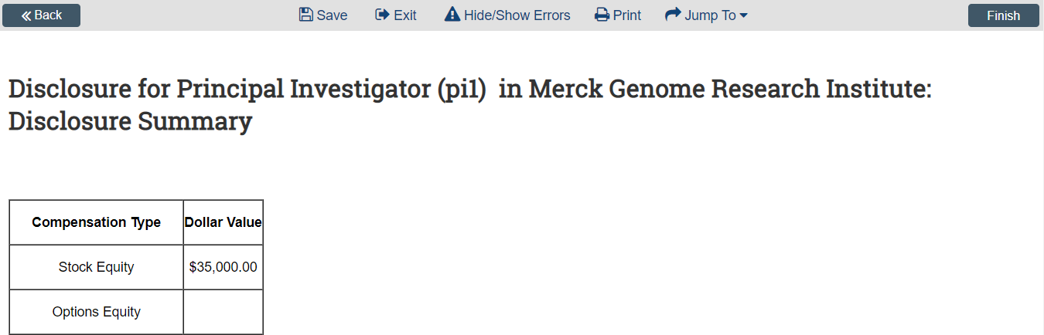
There are no fields to update on this page; it displays a summary of the dollar amounts of any Type(s) of relationships that you have chosen to disclose. Please review the dollar amounts for accuracy.
After you have finished reviewing your Disclosure(s), click the Finish button to save your work and move to the next pages within the SmartForms.

Disclosure Details
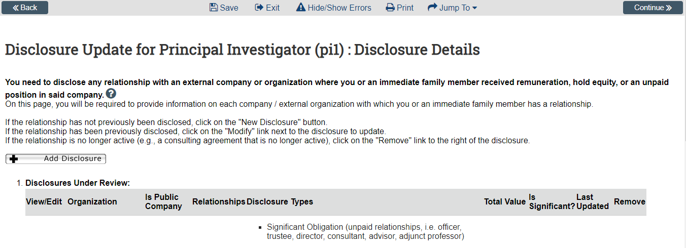
- The Disclosure Details page will now list the new Disclosure that you have created.
- To make any changes to that Disclosure, click the Edit button to its left.
- To create an additional Disclosure, click the Add Disclosure button.
- If you have created Disclosures in the past that have already been reviewed by the COI Committee, they will list here.
- If you need to make any changes to a previous Disclosure, click the Modify button to its left.
- If the relationship for that Disclosure is no active, click the Remove option
Click the Continue button to save your work and move to the next page within the SmartForms.

Assurance and Certification
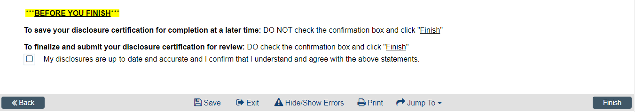
To save your Disclosure Certification for completion at a later time:
- DO NOT check the confirmation box; click the Finish button to exit the SmartForms.
To finalize and prepare to submit your Disclosure Certification for review:
- DO check the confirmation box; click the Finish button to exit the SmartForms.
You have now completed your Annual Certification Disclosure. When you click the Finish button, you will be returned to the Workspace.
If you need to further edit your certification prior to submission, click the Edit button on the top left of the screen, under My Current Actions.
Note: At this point, your certification has not yet been submitted for review.
Please see Submitting Disclosure(s) for Review.

Page left intentionally blank

Submitting Disclosure(s) for Review
In order to submit the Annual Certification Disclosure to the COI Committee for review, the Discloser must complete the following actions, from the Workspace:
- To submit your Disclosure(s) for review, click Submit Disclosures under My Current Actions.
The Click Portal will run a brief check to ensure that all of the required fields have been completed within the SmartForms.
- If an error appears, click the link(s) and update any required fields that were missed. Save your changes, Exit the SmartForms, and then click the Submit button again.
- If there are no errors, a statement will appear in the window.
- Read the statement and then place a checkmark next to the sentence at the bottom of the window. Click OK to submit the Disclosure(s) for review.
- After you submit, check to ensure that the following things have occurred:
- The Status Bar in the upper-left corner of the Workspace has now changed from Draft to Administrative Review.
- Today’s date will appear as the Date Submitted on the Summary tab.
- On the History tab, the most recent action is Disclosures Submitted.

Recalling Submitted Disclosures
If you have submitted your Disclosure(s) for review and feel that you need to make additional modifications prior to its review, you can recall it from submission.
- Click Return COI Certification to Submitter under My Current Actions.
- Select Yes if you are sure you want the Annual Certification Disclosure returned to you, and then click the OK button.
- The Certification will be returned to its former Draft status. You can then make the necessary modifications and re-submit it for review.

The Review Process
Congratulations – your Annual Certification Disclosure has now been submitted to the COI Committee for review!
Submitting Disclosure(s) to the COI initiates a series of activities that may include:
- Administrative Review by the COI Administrator
- Review by the Full COI Committee
Any of these reviews may lead to a request for the submitter to take further action, such as providing clarifications, making requested changes, or agreeing to a management/mitigation plan. Whenever the Discloser needs to act, they receive an email notification and the Annual Certification Disclosure appears in My Inbox for them when they log in to the Click Portal.

Clarification and Change Requests
At points during the review process, clarifications and/or modifications may be requested from the Discloser.
- Clarification Requests
If the COI Administrator has questions regarding the disclosure, the Discloser will receive an email notification. The submission will be in the Administrative (or Committee) Review: Response Pending state, since it now requires an action.

- Change Requests
If the COI Administrator requires you to make changes to your submission prior to approval, the Discloser will receive an email notification. The submission will be in the Administrative (or Committee) Review: Response Pending state, since it now requires an action.
The Discloser is responsible for making any changes necessary, and for responding to the request.

Review the Request Details
- To respond to a request, either click on the link embedded in the email notification or navigate to My Inbox and locate the disclosure with the status of Administrative (or Committee) Review: Response Pending. Click on the Annual Certification Disclosure’s Name to open it.
- Locate the History tab of the submission’s Workspace. The History lists the activity taken on a certification including any comments, attachments, or correspondence added.
- To update the certification, click Edit on the left and make the requested changes. Otherwise go to the next section. You will be able to enter a response to the reviewer before submitting.

Respond to the Request
- Click Submit Changes.
- In the Notes box, type your response to the reviewer.
- Attach any documents that may clarify your changes (optional).
- Click OK. The status of the disclosure should return to Administrative (or Committee) Review.
Note: If no actual edits/changes were needed to the disclosure,
the Discloser can simply provide the written response.

Management/Mitigation Plans
As a result of reviewing your certification, the COI Committee may issue you a plan to manage your conflict(s) of interest.
- To respond to a plan, either click on the link embedded in the email notification or navigate to My Inbox and locate the disclosure with the status of Management (or Mitigation) Plan Required. Click on the Annual Certification Disclosure’s Name to open it.
- Locate the History tab of the submission’s Workspace. The History lists the activity taken on a certification including any comments, attachments, or correspondence added.
- On the Summary tab in the Workspace, click the Management or Mitigation Plan link to open the plan and then review it.

Respond to the Request
- Under My Current Actions, click Submit Response Plan.
- Select Accept to accept the Management Plan.
If you have questions about the plan, select Request Further Clarification and type your questions in the Notes box.
- Attach any documents that may clarify your response (optional).
- Click OK. The status of the disclosure should now be Under Management/Mitigation Plan.

Update Your Certification
All investigators must update their Annual Certification Disclosure within 30 days of discovering or acquiring a significant financial interest (e.g., through purchase, marriage or inheritance).
- Click COI in the top navigation menu.
- Click the Create My Certification button.
- A pop-up window will open. Type the reason for the update and then click OK.
- In the workspace, click the Edit button.
- Update the certification as necessary.

Click the Jump To: menu to go to the page you want to update.
See Disclosure Details to add, edit, or delete disclosure details.

- On the last certification page, select the check box to submit the updated certification, and then click Finish.
- To submit your updated Disclosure(s) for review, click Submit Disclosures under My Current Actions.
The Click Portal will run a brief check to ensure that all of the required fields have been completed within the SmartForms.
- If an error appears, click the link(s) and update any required fields that were missed. Save your changes, Exit the SmartForms, and then click the Submit button again.
- If there are no errors, a statement will appear in the window.
- Read the statement and then place a checkmark next to the sentence at the bottom of the window. Click OK to submit the Disclosure(s) for review.

Conflict of Interest in  Research Committee (CIRC)  Clinical and Translational Research Center  875 Ellicott Street, Room 5018  Buffalo, NY 14203  716.888.4888  coiofficer@buffalo.edu | Research Information Systems (RIS)  UB Commons, Suite 114  University at Buffalo – North Campus  Amherst, NY 14260  716.829.3457  support@research.buffalo.edu

